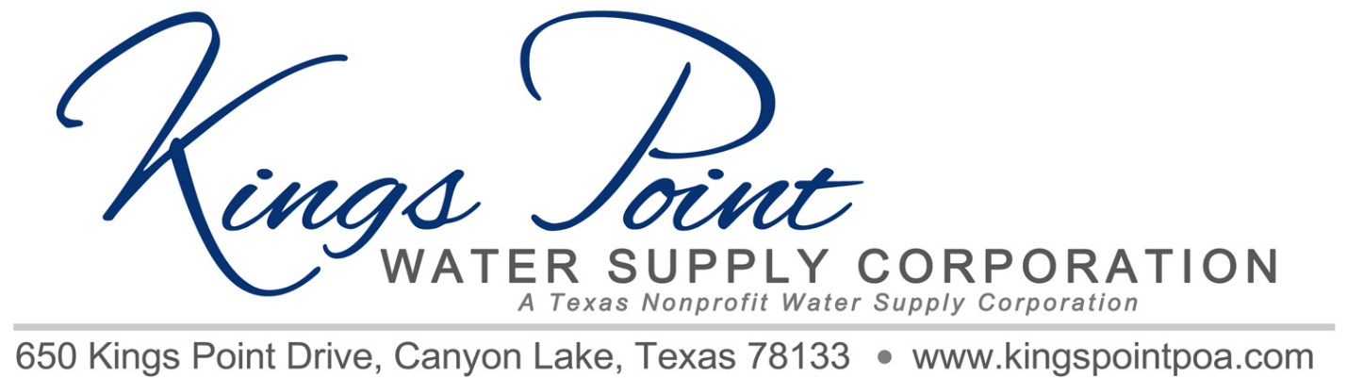
Agenda
Board of Directors Meeting
July 16, 2021 - Noon - Kings Point Pavilion

Call to Order
Determination of Quorum
Proof of Notice
Adoption of Standing Rules
Approval of Previous Minutes
Treasurer's Report
Old Business:
- Valves

New Business:
- Generator Contract Review/Approval
- Propane Tank Costs
- Electrical Power upgrade
- Improvements to Well Site to Accommodate Generator, Propane Tank and Changes Required by PEC
- Fence and new gate
- Federal Income Taxes
- Bleach Prices
- Annual Irrigation Inspections

Any Other Business

Schedule Next Meeting

Discussion
Adjournment

