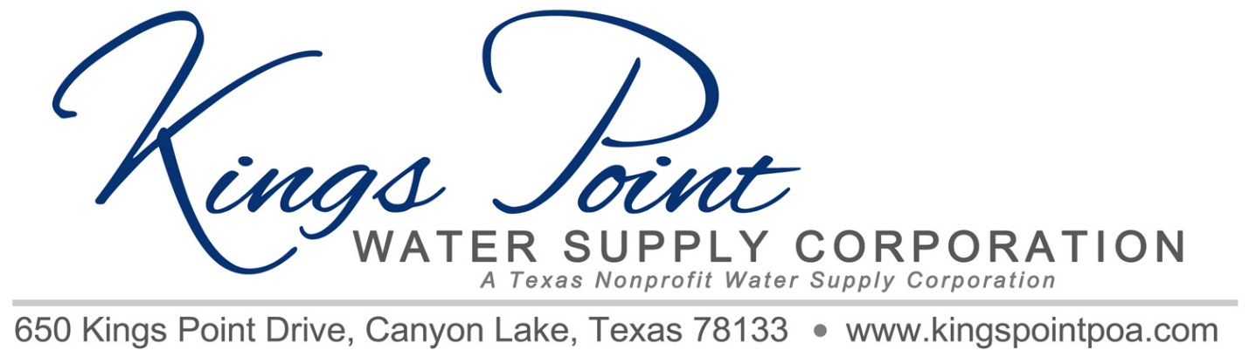
Agenda
Board of Directors Meeting
November 8, 2021 - Noon - Kings Point Pavilion

Call to Order
Determination of Quorum
Proof of Notice
Adoption of Standing Rules
Approval of Previous Minutes
Treasurer's Report
Old Business:
- Generator Status
- Propane Tank Status
- Electrical Power Upgrade Status
- Improvements to Well Site to Accommodate Generator, Propane Tank and Changes Required by PEC

New Business:
1. Pipeline Breaks and Needs for Replacing
- Stage One Bid
- Access Work (Tree Trimming, Etc.)
2. Texas State Legislation Regarding Customer Confidentiality
3. Texas State Legislation Regarding Emergency Plan
4. TCEQ Requirements Regarding Back Flow Devices

Any Other Business

Schedule Next Meeting

Discussion
Adjournment

